**plan55switchingcenter**

**Plan 55 Switching Center**

**A Data Communication Historical Series**

**By Bob Pollard**

**Plan 55 was a 1950s automatic punched paper tape message switching system.**

Western Union’s Plan 55 was an automatic punched paper tape message switching system designed and developed for the US Air Force (USAF) and Department of Defense (DoD) in the mid 1950’s. These switching centers were installed at Air Force Bases around the world. The Centers incorporated advanced electronic technology that allowed messages punched (perforated) in paper tape to be automatically received, routed, stored and delivered.

The Plan 55 system is described in a little more detail because it was the one of the first automatic message switching centers which was installed and in operation prior to the advent of communication computer systems.

Computers in the 1950’s utilized vacuum tubes for the logic gating and some mechanical relays and the systems were physically large, required a high volume of cooling capacity and required a high degree of maintenance. And last, but not least, were expensive to purchase. Also, they were designed to be data processors and were not easily adaptable for message processing requirements. At lower cost and less maintenance, the Plan 55 system was a good alternative to the existing computer systems.

The Plan 55 System used paper tape perforators (punches), paper tape transmitters, many mechanical relays and controls, a vacuum tube matrix for reading addresses and other information, and a patchable director unit. The punched paper tape was the memory storage and history media.

All message input and output from the switching center, utilized the Baudot (modified) Code Set. This was a five-bit code, with additional start and stop bits. All tributaries operated at individually assigned speeds between 50 and 100 Words per Minute (WPM) and used Teletype (teletypewriter) type of equipment. There was also a trunk line(s) connection between the various switching centers. The terms ‘words per minute’ (WPM), ‘characters per minute’ (CPM) or ‘Characters’ are inter-changeable when used within this overview.

Each tributary (terminal) assigned to the adjacent Plan 55 center was connected to a paper tape perforator device for input to the center and to a paper tape transmitter for output from the center. Full duplex operation (simultaneous send-receive operation) for each tributary was allowed.

A cabinet, about 3 feet wide by 7 feet tall, contained the necessary equipment to accommodate two-line connections, therefore, each the switching center had the number of cabinets necessary to handle the assigned line connection requirements. There was an input side (from tributary) cabinet and an output side (to tributary) cabinet. The input side cabinets were usually lined up on one side of the center and the output side cabinets were on the other side of the center.

A single row or double row of cabinets was used as necessary. When a double row was used the cabinet, fronts faced each other with an aisle between them. This allowed access to the equipment in either row by using one aisle. On the input side (front) the cabinet contained two paper tape perforators (punch) operating at 50 to 100 WPM, two "Loop Gate" paper tape transmitters (200 WPM), two paper tape storage bins, four tape reels and some indicator lamps and switches. A vacuum tube matrix, power supply and other miscellaneous components were located on the backside of the input cabinet. On the output side the cabinet contained two paper tape re-perforators (punch) operating at 200- WPM, two paper tape transmitters (50 to 100 WPM), two tape storage bins, four tape reels and some indicator lamps and switches. The term “re-perforator was used to identify the fact a previously punched tape, cross-office from the receive perforator, was being re-punched for output.

Figure 1-1 is a front view of a row of input (receive from tributary) cabinets.

The equipment and component cabinets were approximately the same size. These cabinets were lined up behind the input side cabinets with an aisle down the middle, which allowed access to the hardware/ electrical components. It was like working in a tunnel when it was necessary to access the relay drawers, power supplies, vacuum tube banks and other miscellaneous equipment. The equipment cabinets contained drawers of electrical-mechanical relays and these drawers were stacked vertically and side by side. They slid out into the aisle on drawer slides when it was necessary to access the relays, which were protected by a removable cover. I suppose these relays could be considered a pre- transistor gate media since they were activated to make cross-center (office) line connections and initiate various controls and signals.

Also, cross-office character bits were transmitted in parallel. The required number of relay drawers was determined by the number of input cabinet / devices installed in the switching center.

Figure 1-2 provides an internal view of the equipment (maintenance) aisle. The relay drawers are on the left and the vacuum tube panels are on the right.

Figure 1-3 provides a view of the vacuum tube panels in the equipment (maintenance) aisle.

Figure 1-4 shows the relay drawers in the equipment (maintenance) aisle.

The cabinets were painted medium to dark green with a "crackle" finish and had doors that closed in front of the paper tape perforators and transmitters on both input and output cabinets. This allowed the cabinets to have a closed and clean front appearance. The paper tape storage bins were approximately 2 feet high by 2 feet wide and 1 inch deep (or thick) and were located at the bottom of the cabinet behind a removable front panel. The tape, as it was being received through the paper tape perforator, was fed into the storage bins for future transmission. The other end of the tape was held in place across the paper tape transmitter. A tape tension device, along with other control signals, started or stopped the paper tape transmitter. More on these features later. A tape reel containing blank tape provided the tape for the perforator and another reel took up the punched tape as it fed through the transmitter. This punched tape became the history file.

The paper tape perforators/reperforator, both for center input and output, created a ‘Chad-less’ punched tape. In other words, the tape circles punched for the code pulses were not disconnected from the paper tape. Each punch pin only punched a hole in the tape on three sides (3/4 around the circle) of the hole. This allowed the punched-out tape (hole) to stay attached to the paper tape, and not create ‘donut holes’ (Chad) that would end up all over the floor and in the equipment. The five-bit code was punched across (column) the tape, which determined the tape width.

The ‘loop gate’ transmitter on the center input side had a sliding shuttle, which allowed the header (addresses) to be read without transmitting the information until the entire message was received. This feature created a loop between the front side and backside of the sliding shuttle. There was an opening of about 1-inch between the front bar and the rear bar of the shuttle, and across the opening it was just wide enough to accommodate the punched tape. When a message was being received through the perforator the tape between the perforator and the ‘Loop gate’ transmitter would go slack, allowing the transmitter to start. When the transmitter started the shuttle would be to the right (rest position) and would feed the tape through and read the tape on the left side of the shuttle. Since the tape contained delete characters (fill characters) the tape would continue to feed until a SOM (Start of Message) was detected.

When the SOM was detected the shuttle would slide to the left. The transmitter would then start reading the tape on the right side of the shuttle. The left side of the shuttle would not allow the tape to feed; thus, causing a loop to rise as the tape was read. The purpose of this function was to read the header (routing indicators) information first. This allowed the routing of the message, across center, to be determined without transmitting the message information until the EOM (End of Message) was detected at the perforator. Single or multiple addresses would be handled in this manner and all cross-center connections would be made sequentially after the addresses were read, thus allowing the message to be sent to all output (send) reperforators simultaneously. When the EOM was detected via the perforator the shuttle on the transmitter would slide to the right and start feeding and reading the tape on the left side of the shuttle. This allowed the message data to be transmitted to the proper re-perforator(s) on the output side of the center.

The cross-center connections had been established during the address read cycle on the right side of the shuttle. The cross-center transmission and address reading was performed at 200 WPM. If one or more of the cross-center reperforators (center output) were busy the ‘loop gate’ transmitter would not transmit until all connections could be accomplished.

Each message received or input to the Switching Center contained a SOM, priority symbol (optional), routing address(s), referred to as the header, the message text and an EOM. Multiple addresses were allowed and I believe one to five different addresses could be used in a single message. The SOM consisted of a ZCZC sequence, the priority was 2 characters, the address(s) was a multiple of Baudot characters, with each address separated by a space character, the text could be any characters (excluding SOM and EOM) and any length, and the EOM consisted of 4 Ns (NNNN).

Figure 1-5 shows the ‘loop gate’ transmitter, perforator, tape reels and tape tension controls in the receiving side (input) cabinet.

The tape storage bins become important when a cross-center output line was busy or a low speed tributary on the output side received a high number of messages. Also, long messages on the input side required storage until the EOM was read.

The tape storage bins, especially on the center output side, frequently became overloaded and the tape had to be handled manually. The operators would pull the tape out of the overloaded bin and wind a figure 8 around their for-finger and thumb and would lay this big ball of tape on the floor between the bin out side and the transmitter input. This was done to keep the tape from tangling while it was being fed through the output transmitter.

Note:Refer to the Plan 55 supplement for some personal comments and a few miscellaneous pictures.

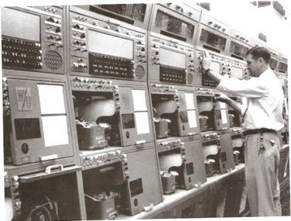

**Figure 1-1: Front view of a row of input (receive from tributary) cabinets**

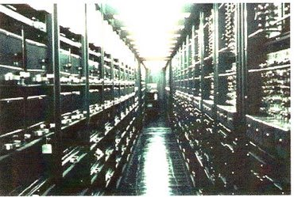

**Figure 1-2:** **Internal view of the equipment (maintenance) aisle. The relay drawers are on the left and the vacuum tube panels are on the right.**

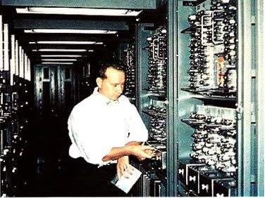

**Figure 1-3:** **Vacuum tube panels in the equipment (maintenance) aisle**

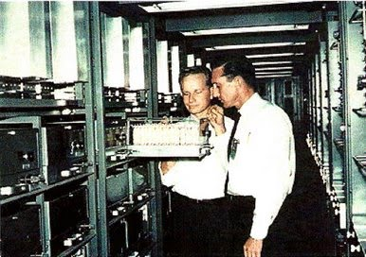

**Figure 1-4:** **Relay drawers in the equipment (maintenance) aisle**

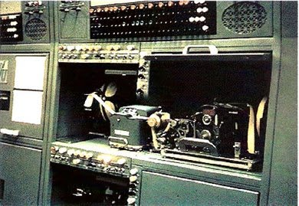

**Figure 1-5:** **Loop gate transmitter, perforator, tape reels and tape tension controls in the receiving side (input) cabinet.**